**PYTHON PROGRAM WITH QUEUE**

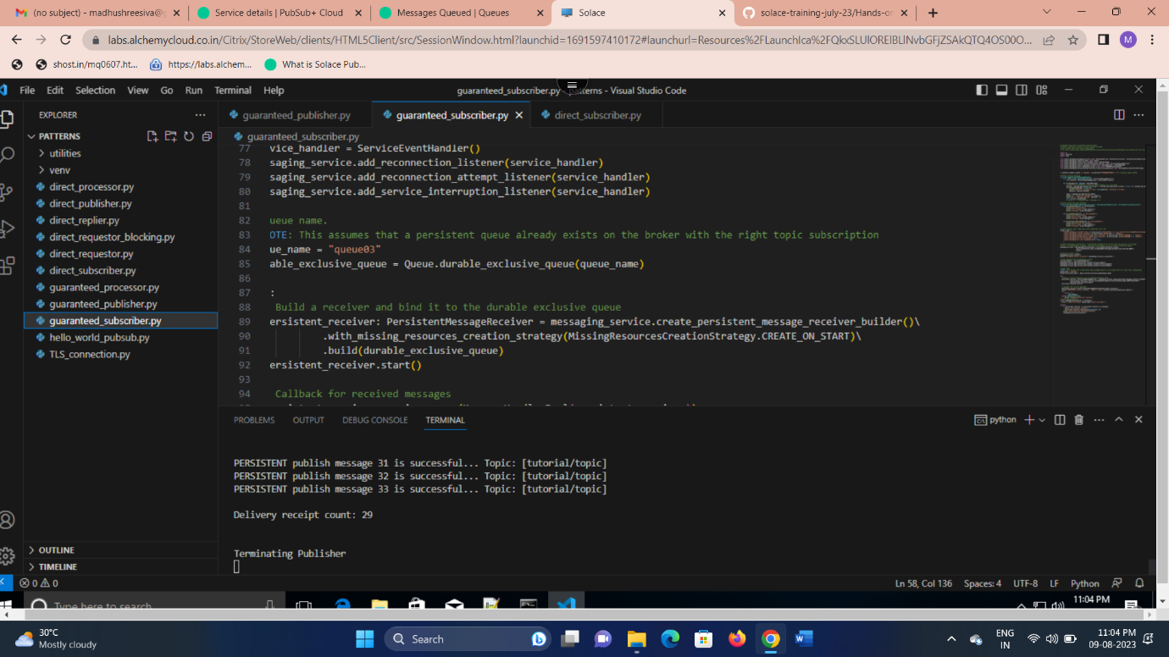

**TOPIC SUBSCRIPTION**

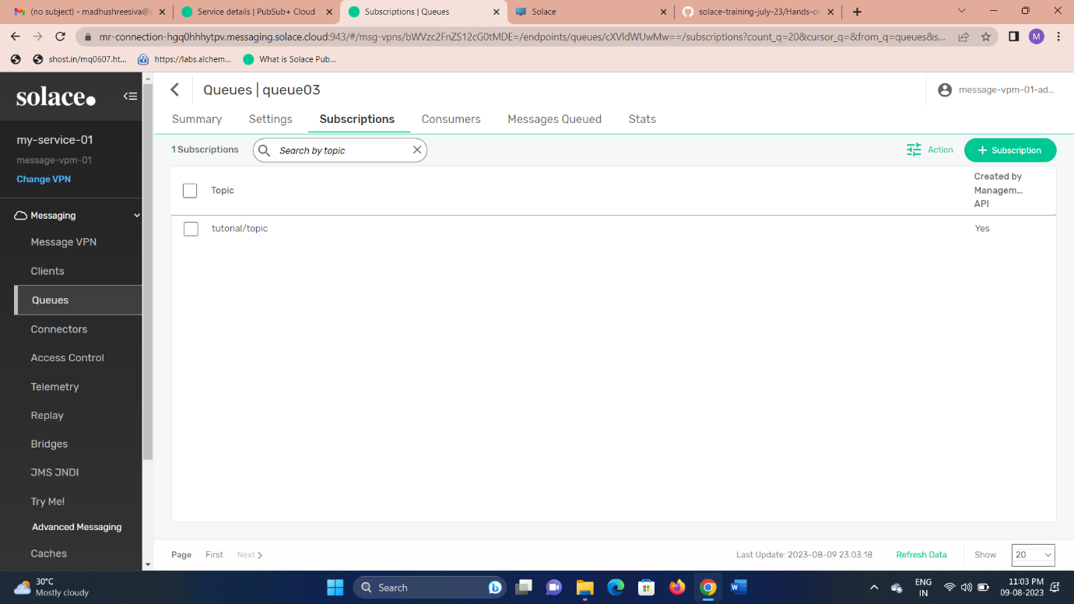

**PUBLISH THE MESSAGE TO QUEUE**

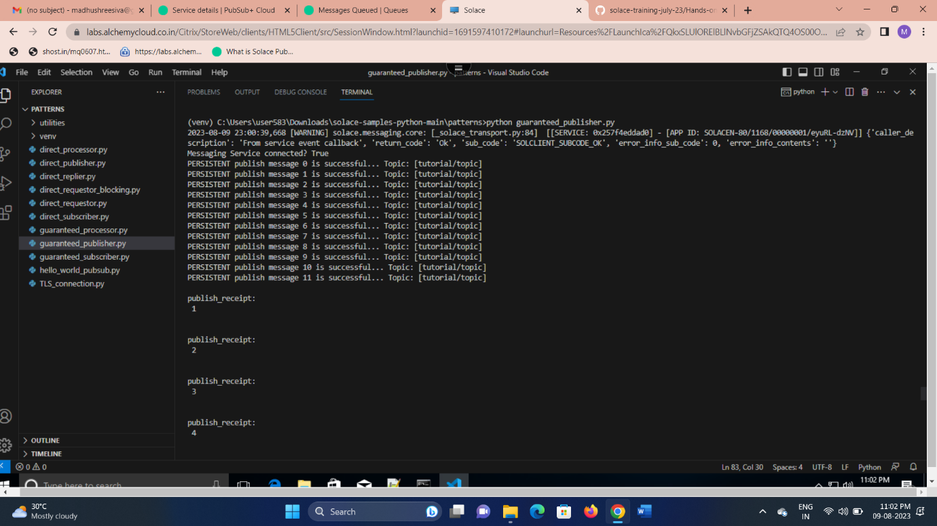

**MESSAGE QUEUED**

